Tomcat Server Setup :

Step 1) Installation Tomcat and make sure that below environment variables have been set up in order to run Tomcat locally.

* CATALINA_HOME= *(address where your Apache Tomcat is)*

C:\Program Files\Java\apache-tomcat-7.0.59\apache-tomcat-7.0.59

* JAVA_HOME= *(address where your JDK is)*

C:\Program Files\Java\jdk1.8.0_25;

* JRE_HOME= ; (address where your JRE is)

C:\Program Files\Java\jre1.8.0_25

* CLASSPATH=%JAVA_HOME%\bin;%JRE_HOME%;%CATALINA_HOME%\lib

Step 2) Testing Tomcat as it was installed and set up properly

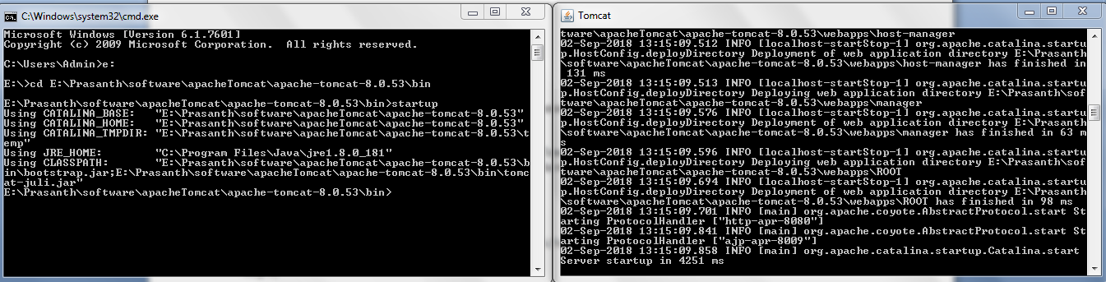

2) Building WAR file manually:

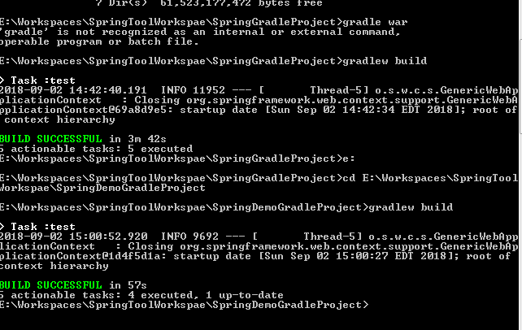

Location of the WAR file crated as : <GIT Project Worksapce Directory>\build\libs

3) Deploy the WAR file into TOMCAT server manually , start the Tomcat server after copy the WAR file

Location path : <<TOMCAT server install locatkion>>/webapps folder

4) Testing

Test the application GET service from IE Browser

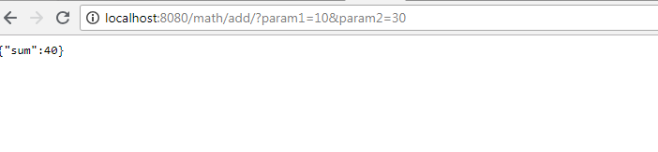

Down load the SOAP UI project from GIT and Import into SOAP UI Project

<<GIT Source Code Location>>/ SpringDemoGradleProject /RESTTestProject-soapui-project.xml

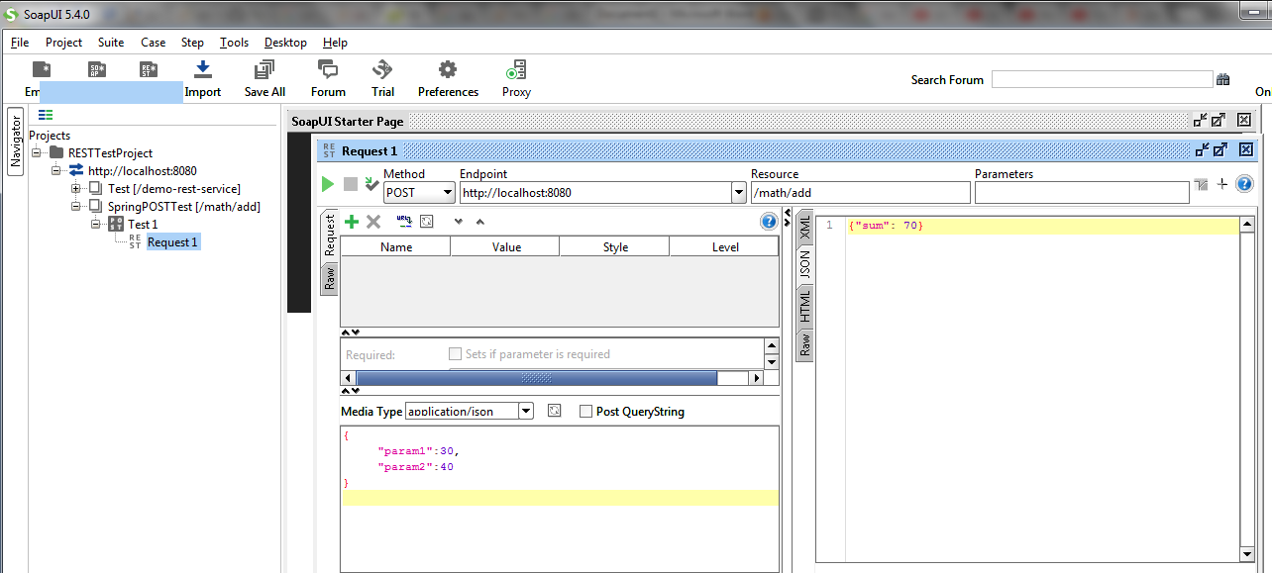

2) Steps for AWS cloud Solution :

2.1) AWS Service - Elastic Beanstalk

2.3) Create a new application

2.3) Create an environment

a) Webserver Environment , Tomcat Platform and upload WAR file

2.4) Copy the URL service into application.properties , service.url

a) Save the project and create new WAR file with updated URL and deploy again into AWS

2.5) Test using above URL( Update with new URL ) and test the same from SOAP UI as well.